PROJECT SUBMISSION REPORT
____________________________________________________________

CivicSense
Crowdsourced Civic Issue Reporting
and Resolution System

AI-Powered • Real-Time • Community-Driven
____________________________________________________________

Version 1.0 | March 2026

Table of Contents
1. Abstract 3
2. Introduction 4
3. Literature Survey & Market Analysis 5
4. Existing Systems & Comparative Analysis 7
5. Proposed System 9
6. System Architecture & Design 11
7. Technology Stack 13
8. Database Design 14
9. Implementation & Screenshots 16
10. AI & Machine Learning Features 25
11. Innovation & Unique Contributions 27
12. Testing & Validation 29
13. Future Scope 30
14. Conclusion 31
15. References 32

1. Abstract
CivicSense is a full-stack, AI-powered crowdsourced civic issue reporting and resolution system designed to bridge the communication gap between citizens and municipal authorities. The platform enables residents to report infrastructure problems such as potholes, broken streetlights, garbage overflow, flooding, and vandalism through geo-tagged photographs captured directly from their mobile devices. Upon submission, an artificial intelligence engine powered by Google Gemini 1.5 Flash automatically analyzes the image and description to classify the issue category, assign a priority level, generate a confidence score, and suggest corrective actions.
The system implements a three-role architecture consisting of Citizens (Helpers), Field Workers, and Administrators, each with dedicated portal interfaces optimized for their workflows. A smart auto-assignment algorithm leverages the Haversine distance formula combined with workload balancing and zone-matching to optimally dispatch field workers to reported issues. Field workers receive real-time task notifications, interactive map views with navigation support, and can document resolution through before-and-after photo evidence.
The administrative console provides comprehensive analytics dashboards with category distribution charts, priority analysis, 7-day activity timelines, geographic heat maps, worker management tools, community engagement features, and a full maintenance scheduling module. The platform also includes AI-powered duplicate detection using geo-proximity clustering, a gamified leaderboard system to incentivize citizen participation, and automated email notifications powered by Resend for transparent issue resolution tracking.
Keywords: Civic Technology, Crowdsourcing, AI Image Analysis, Smart City, Issue Tracking, Geolocation, Real-time Monitoring, Field Worker Management, Community Engagement

2. Introduction

2.1 Background
Urban infrastructure maintenance remains one of the most persistent challenges facing municipalities worldwide. Potholes cause vehicle damage and accidents, broken streetlights create safety hazards, overflowing garbage bins attract disease-carrying pests, and flooding from blocked storm drains disrupts daily life. Despite these critical issues, the traditional process for reporting and resolving civic problems relies on outdated channels such as phone calls to government offices, written complaints, or in-person visits to municipal wards. These methods suffer from slow response times, lack of accountability, poor tracking visibility, and significant information loss between the citizen and the resolution team.

2.2 Problem Statement
The core problem addressed by CivicSense is the absence of a unified, intelligent, and transparent platform that connects the entire lifecycle of civic issue management: from citizen reporting through AI-assisted triage, automated worker dispatch, real-time field operations, and verified resolution with community feedback. Existing solutions either focus narrowly on reporting (without field worker integration), lack AI capabilities for automated classification, or are prohibitively expensive enterprise solutions inaccessible to smaller municipalities.

2.3 Objectives
- Develop a mobile-responsive web platform for citizens to report civic issues with geo-tagged photographs and automatic GPS location capture.
- Implement AI-powered image analysis using Google Gemini to automatically categorize issues, assign priority levels, and suggest corrective actions.
- Design a smart auto-assignment algorithm that optimally dispatches field workers based on proximity (Haversine distance), current workload, and zone assignment.
- Create dedicated portal interfaces for three user roles: Citizens, Field Workers, and Administrators, each optimized for their specific workflows.
- Build comprehensive analytics dashboards with real-time charts, geographic visualizations, and performance metrics for data-driven municipal decision-making.
- Integrate community engagement features including announcements, feedback mechanisms, and a gamified leaderboard to sustain citizen participation.
- Implement a maintenance scheduling module for proactive infrastructure management with inspections, asset tracking, and recurring task automation.

2.4 Scope
CivicSense targets municipalities, smart city initiatives, and local government bodies seeking to modernize their civic complaint resolution workflows. The system is designed to be scalable from small towns to metropolitan cities, with role-based access control, real-time notifications, and a cloud-native architecture deployed on Vercel with Supabase PostgreSQL for database operations. The initial deployment focuses on the New Delhi metropolitan area with GPS-based issue mapping.

3. Literature Survey & Market Analysis

3.1 Evolution of Civic Technology
Civic technology, commonly known as "civic tech," has evolved significantly over the past two decades. The earliest digital civic engagement platforms emerged in the mid-2000s with tools like FixMyStreet (2007) by mySociety in the United Kingdom, which pioneered the concept of location-based citizen reporting for street-level problems. This was followed by SeeClickFix (2008) in the United States, which introduced mobile-first reporting with photo documentation capabilities.
The 311 system, originally a non-emergency phone service adopted by cities like New York (1996) and Boston (2007), transitioned to digital platforms with mobile apps and web interfaces. Boston's Citizen Connect became a national model for multi-channel civic engagement. However, these systems primarily focused on the intake side of the workflow, with limited integration into field operations, asset management, or AI-assisted decision-making.

3.2 Market Landscape
The global civic engagement platform market was valued at approximately USD 7.3 billion in 2023, with projections indicating growth to USD 15.8 billion by 2032 at a compound annual growth rate (CAGR) of 9.1%. Key growth drivers include the proliferation of smartphone adoption, increasing citizen expectations for digital government services, and the emerging integration of artificial intelligence and machine learning capabilities into civic workflows. According to industry research, only 35% of government organizations are currently experimenting with AI, while 61% have not adopted any AI capabilities, representing a significant untapped opportunity.

3.3 Related Academic Work
Recent academic literature has explored various dimensions of civic technology. Aidrix (2024) proposed an AI-powered civic issue reporting and tracking platform framework that emphasizes automated image analysis for issue classification. The International Journal of Engineering Research and Technology (IJERT) published a theoretical framework for AI-assisted civic issue reporting and validation in smart cities (2025), highlighting the potential for deep learning models to process crowdsourced imagery for infrastructure defect detection. Research on gamification for civic participation has demonstrated that leaderboard systems and achievement badges can increase sustained engagement by 40-60% compared to non-gamified platforms.
However, most academic work remains theoretical or addresses individual components (e.g., only image classification, or only task routing) rather than providing an integrated end-to-end system. CivicSense addresses this gap by combining AI analysis, smart assignment, field operations, and community engagement in a single, production-ready platform.

4. Existing Systems & Comparative Analysis

4.1 FixMyStreet (mySociety, UK)
FixMyStreet is an open-source platform developed by mySociety that allows UK citizens to report street-level problems such as potholes, broken streetlights, and graffiti by entering a postcode or dropping a pin on a map. Reports are automatically routed to the responsible local council. The platform is free for citizens and has been deployed in over 20 countries. However, FixMyStreet focuses solely on the reporting intake side, with no integrated field worker dispatch, AI-powered classification, gamification, or maintenance scheduling capabilities. Council participation varies widely, and the platform cannot identify comparative problem areas without supplementary data analysis.

4.2 SeeClickFix (CivicPlus, USA)
SeeClickFix, acquired by CivicPlus in 2019, provides a mobile app for citizens to report neighborhood issues with photo and video documentation. The platform includes a government staff portal with basic analytics, notifications for area-based issues, and data export capabilities. While SeeClickFix offers a more polished user experience than FixMyStreet, it lacks AI-powered categorization, real-time field worker dispatch, gamified engagement, and transparent pricing. The platform is primarily a CRM system for managing citizen requests rather than an integrated operations management tool.

4.3 Boston 311 / Citizen Connect
Boston's 311 system, accessible via the BOS:311 app, phone, and web, is an award-winning multi-channel civic engagement platform that has been replicated across Massachusetts and nationally. It provides 24/7 availability and integrates with the city's work order management system. However, the platform is designed for large municipalities with existing IT infrastructure, lacks AI capabilities, and does not offer open-source or SaaS deployment options for smaller cities.

4.4 Other Platforms
Additional platforms in the market include Accela Civic Platform (enterprise-grade with GIS integration and field worker tools, but at prohibitive cost), PublicStuff (acquired by Accela, with multi-channel intake and multilingual support starting at $1,000/year), and mySidewalk (focused on data analytics rather than issue reporting). Smart City 311 systems offer basic cloud-based reporting but lack advanced features. The Open311 API standard provides interoperability but is not a platform itself.

4.5 Comparative Analysis Table
Feature | FixMyStreet | SeeClickFix | BOS:311 | Accela | CivicSense
Photo Reporting | Yes | Yes | Yes | Yes | Yes
GPS Location | Yes | Yes | Yes | Yes | Yes
AI Categorization | No | No | No | No | Yes
AI Priority Scoring | No | No | No | No | Yes
Duplicate Detection | No | No | No | No | Yes (AI)
Field Worker Dispatch | No | No | Limited | Yes | Yes (Smart)
Real-time Map View | No | Limited | No | Yes | Yes
Navigation Integration | No | No | No | Limited | Yes (Google)
Gamification/Leaderboard | No | No | No | No | Yes
Analytics Dashboard | Basic | Moderate | Basic | Moderate | Advanced
Community Engagement | Comments | Alerts | Minimal | No | Full Suite
Maintenance Scheduling | No | No | No | Yes | Yes
Asset Tracking | No | No | No | Yes | Yes
Email Notifications | Limited | Yes | Yes | Yes | Yes (Auto)
Open Source | Yes | No | No | No | Yes
Cost | Free | Custom | Custom | Enterprise | Free/Open

As the comparative analysis demonstrates, CivicSense is the only platform that integrates AI-powered classification, smart auto-assignment, gamification, comprehensive analytics, community engagement, and maintenance scheduling into a single, open-source solution accessible to municipalities of all sizes.

5. Proposed System

5.1 System Overview
CivicSense is a comprehensive, production-ready web application that digitizes the entire lifecycle of civic issue management. The system connects three distinct user roles through dedicated portal interfaces, each designed with role-specific workflows and capabilities. The platform leverages cutting-edge technologies including React 19 for the frontend, Vercel Serverless Functions for the API layer, Supabase PostgreSQL with Prisma ORM for the database, Clerk for authentication, and Google Gemini 1.5 Flash for AI-powered image analysis.

5.2 Three-Role Architecture

5.2.1 Citizen (Helper) Portal
The Citizen Portal serves as the primary interface for residents to engage with municipal services. Citizens can capture photos of civic issues using their device camera or upload existing images, with automatic GPS coordinate extraction for precise location tagging. The portal includes a personalized dashboard showing report statistics, a real-time tracking view for submitted reports with status timeline progression, and a community leaderboard that ranks contributors by their reporting activity and resolution impact.

5.2.2 Field Worker Portal
The Field Worker Portal provides an operations-focused interface for municipal workers assigned to resolve reported issues. Workers receive real-time task assignments with priority indicators, can view all assigned tasks on an interactive map with color-coded status markers, and access one-click Google Maps navigation to issue locations. The workflow supports a complete resolution cycle: accepting tasks, marking them in-progress, uploading completion photos as proof of resolution, and escalating complex issues. Workers can toggle their availability status and track their performance metrics.

5.2.3 Administrator Console
The Administrator Console is a comprehensive management dashboard for municipal authorities. It provides real-time overview of all reported issues with interactive charts showing category distribution, priority analysis, 7-day activity timelines, and geographic heat maps. Administrators can trigger AI analysis on reports, auto-assign workers using the smart algorithm, detect duplicate reports, manage field workers (create accounts, assign zones, monitor availability), engage the community through announcements and feedback channels, and manage maintenance schedules including inspections, asset history tracking, and recurring task automation.

5.3 Key Workflow
The complete workflow follows this sequence: (1) A citizen captures a photo and submits a report with title, description, and category. (2) The AI engine analyzes the image and text to classify the issue type, assign priority, and generate an analysis summary with suggested actions. (3) An administrator reviews the AI analysis and triggers auto-assignment, which selects the optimal field worker based on proximity, workload, and zone. (4) The assigned worker receives a notification, navigates to the location, resolves the issue, and uploads a completion photo. (5) Automated emails are sent to the original reporter and all administrators confirming resolution. (6) Analytics and community dashboards update in real-time to reflect the resolution.

6. System Architecture & Design

6.1 High-Level Architecture
CivicSense follows a modern cloud-native architecture pattern with clear separation of concerns across the frontend, API, database, and external service layers. The frontend is a React 19 Single Page Application (SPA) built with Vite 7 and served through Vercel's CDN. The API layer consists of 12 serverless functions deployed on Vercel, handling CRUD operations, AI processing, smart assignment, authentication, and notifications. The database layer uses Supabase PostgreSQL with Prisma ORM for type-safe data access and supports real-time subscriptions through Supabase Realtime channels.
Layer | Technology | Purpose
Frontend | React 19 + Vite 7 + TailwindCSS | SPA with lazy-loaded routes per role
Authentication | Clerk (OAuth + Email/Password) | Session management, JWT tokens, RBAC
API Layer | Vercel Serverless Functions (12) | Business logic, CRUD, AI, notifications
ORM | Prisma 5.22 (7 models) | Type-safe database access with migrations
Database | Supabase PostgreSQL | Relational data storage with real-time
Storage | Supabase Storage (2 buckets) | Image storage for reports and completions
AI Engine | Google Gemini 1.5 Flash | Multimodal image + text analysis
Maps | Leaflet + OpenStreetMap | Interactive map visualization
Email | Resend API | Transactional email notifications
Webhooks | Svix | Clerk event synchronization

6.2 Data Flow Diagram
The data flow in CivicSense follows a clear path: Citizen submits report (image + GPS + form data) → API creates report in database and uploads image to Supabase Storage → AI engine receives report for analysis (image base64 + description sent to Gemini) → AI results (category, priority, confidence, summary, action) stored back on report → Admin triggers auto-assign → Algorithm scores available workers (50% proximity + 30% workload + 20% zone) → Task created and worker notified → Worker resolves and uploads completion photo → Email sent to reporter and admins → Analytics updated in real-time.

6.3 Report Status State Machine
Reports follow a defined state machine with seven possible states: Pending (initial submission) → Analyzing (AI processing triggered) → Assigned (worker dispatched) → In Progress (worker started) → Resolved (completion confirmed). Additional terminal states include Duplicate (detected by AI proximity check) and Escalated (worker-initiated for complex issues). Each state transition triggers corresponding database updates, notifications, and analytics refresh.

7. Technology Stack

7.1 Frontend Technologies
Technology | Version | Purpose
React | 19.1.1 | UI component library with hooks and lazy loading
Vite | 7.1.2 | Next-generation build tool for fast development
React Router DOM | 7.9.1 | Client-side routing with code splitting
TailwindCSS | 3.4.17 | Utility-first CSS framework for responsive design
Recharts | 3.2.1 | Declarative chart library (pie, bar, line, area)
Leaflet | 1.9.4 | Interactive map library with OpenStreetMap tiles
React-Leaflet | 5.0.0 | React wrapper for Leaflet components
Lucide React | 0.544.0 | Modern icon library (300+ SVG icons)
date-fns | 4.1.0 | Lightweight date formatting utility
Axios | 1.12.2 | Promise-based HTTP client
clsx + tailwind-merge | 2.1.1 / 3.5.0 | Conditional class merging utilities

7.2 Backend Technologies
Technology | Version | Purpose
Vercel Serverless | N/A | 12 API endpoints as serverless functions
Prisma ORM | 5.22.0 | Type-safe database client with 7 models
Supabase PostgreSQL | N/A | Managed PostgreSQL with real-time and storage
Clerk | 5.61.4 | Authentication (OAuth + email), session management
Clerk Backend | 3.2.3 | Server-side token verification and user creation
Google Generative AI | 0.24.1 | Gemini 1.5 Flash for multimodal analysis
Resend | 6.9.4 | Transactional email service
Svix | 1.89.0 | Webhook event delivery and signature verification

8. Database Design

8.1 Entity-Relationship Overview
The database schema consists of 7 interconnected models managed through Prisma ORM with PostgreSQL as the underlying database engine. The schema implements a normalized relational design with foreign key relationships, cascading operations, and strategic indexing for performance. Connection pooling is handled through Supabase's pgbouncer (port 6543) for runtime queries, with a direct connection (port 5432) reserved for schema migrations.

8.2 Model Specifications

8.2.1 Profile Model
Field | Type | Description
id | String (PK) | Clerk user ID (external auth sync)
fullName | String | User's display name
email | String (Unique) | Email address
phone | String? | Optional phone number
avatarUrl | String? | Profile image URL
role | Enum (helper|admin|worker) | Access control role, default: helper
createdAt | DateTime | Account creation timestamp

8.2.2 Report Model
Field | Type | Description
id | UUID (PK) | Auto-generated unique identifier
reporterId | String (FK → Profile) | Submitting citizen's ID
title | String | Issue title (e.g., 'Pothole on Main Street')
description | String? | Detailed issue description
imageUrl | String | Supabase Storage public URL
lat / lng | Float | GPS coordinates of issue location
address | String? | Optional reverse-geocoded address
category | Enum (6 types) | pothole|garbage|streetlight|flooding|vandalism|other
status | Enum (7 states) | pending|analyzing|assigned|in_progress|resolved|duplicate|escalated
priority | Enum (4 levels) | critical|high|medium|low (default: medium)
aiCategory | String? | AI-classified category
aiPriority | String? | AI-assigned priority
aiConfidence | Float? | AI confidence score (0.0–1.0)
aiSummary | String? | AI-generated analysis summary
aiSuggestedAction | String? | AI-recommended corrective action
duplicateOfId | UUID? (FK → Report) | Self-referencing link for duplicates

8.2.3 Worker Model
The Worker model extends the Profile with operational fields: zone assignment, real-time GPS coordinates (currentLat, currentLng), availability toggle (isAvailable), location freshness timestamp (lastLocationUpdate), active task counter (activeTaskCount), and career completion metric (totalCompleted). The Worker has a one-to-one relationship with Profile and a one-to-many relationship with Task assignments.

8.2.4 Task Model
The Task model represents work assignments linking Reports to Workers. It tracks the complete lifecycle with fields for: assignedBy (admin who triggered assignment), status (assigned | in_progress | completed | cancelled | escalated), before/after images for proof of resolution, worker notes, and precise timestamps for assignment, start, and completion events.

8.2.5 Supporting Models
The Notification model stores real-time alerts with fields for type (task_assigned | task_completed | report_update | alert), read status, and JSON metadata for contextual linking. The Alert model captures critical severity issues auto-generated when AI classifies a report as critical priority, with acknowledgment tracking for administrative response.

8.3 Database Indexing
Strategic indexes are applied on: Report.status (status filtering), Report.category (category-based queries), Report.reporterId (user-specific report retrieval), and a composite index on (Report.lat, Report.lng) for geo-proximity duplicate detection queries. Notification.userId is indexed for efficient per-user notification fetching.

9. Implementation & Screenshots

9.1 Landing Page
The CivicSense landing page serves as the entry point for all users, featuring the platform's branding, key statistics (500+ issues resolved, 3 roles, AI-powered auto-assignment), and role selection cards for Citizens, Field Workers, and Administrators. Each card describes the role's capabilities and provides a direct link to the respective portal.
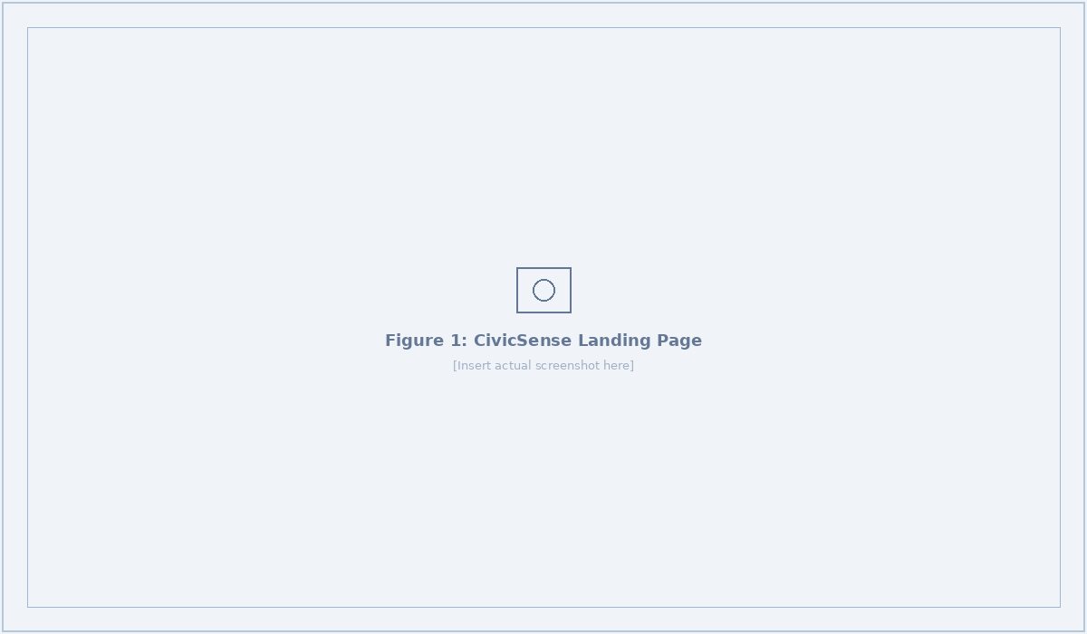
Figure 1: CivicSense Landing Page with role selection cards

9.2 Citizen Portal

9.2.1 Home Dashboard
Upon login, citizens are greeted with a personalized dashboard displaying their reporting statistics across four categories: Total reports, Pending, In Progress, and Resolved. The dashboard also features a prominent 'Report a New Issue' call-to-action card and a list of recent reports with real-time status indicators.
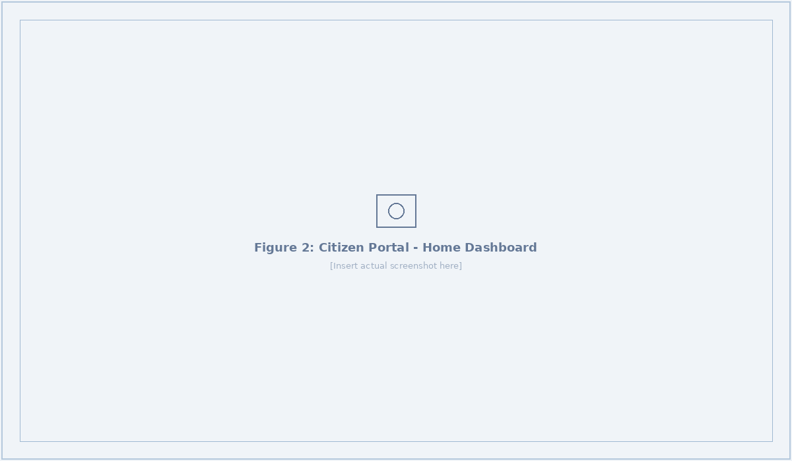
Figure 2: Citizen Portal Home Dashboard

9.2.2 Report Issue Form
The report submission form follows a streamlined mobile-first workflow: citizens first capture a photo using the device camera (via browser getUserMedia API) or upload an existing image. GPS coordinates are automatically extracted with accuracy metadata displayed (e.g., '~103m - consider moving outdoors'). The form then collects a title, optional description, and category selection from six predefined types. Upon submission, the image is uploaded to Supabase Storage and the report is sent to the AI analysis pipeline.
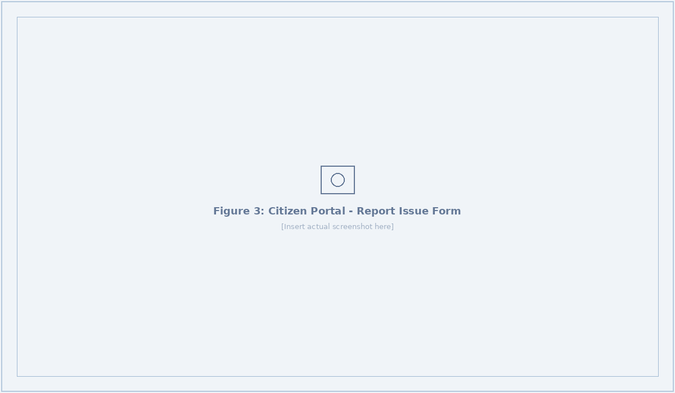
Figure 3: Citizen Portal - Report Issue Form with GPS and Camera

9.2.3 My Reports
The My Reports page allows citizens to track the complete lifecycle of their submitted reports with real-time status updates. Each report displays its title, status badge, category tag, priority level, and timestamps. Citizens can see when their report transitions through each stage: from pending through AI analysis, worker assignment, in-progress resolution, and final completion confirmation.
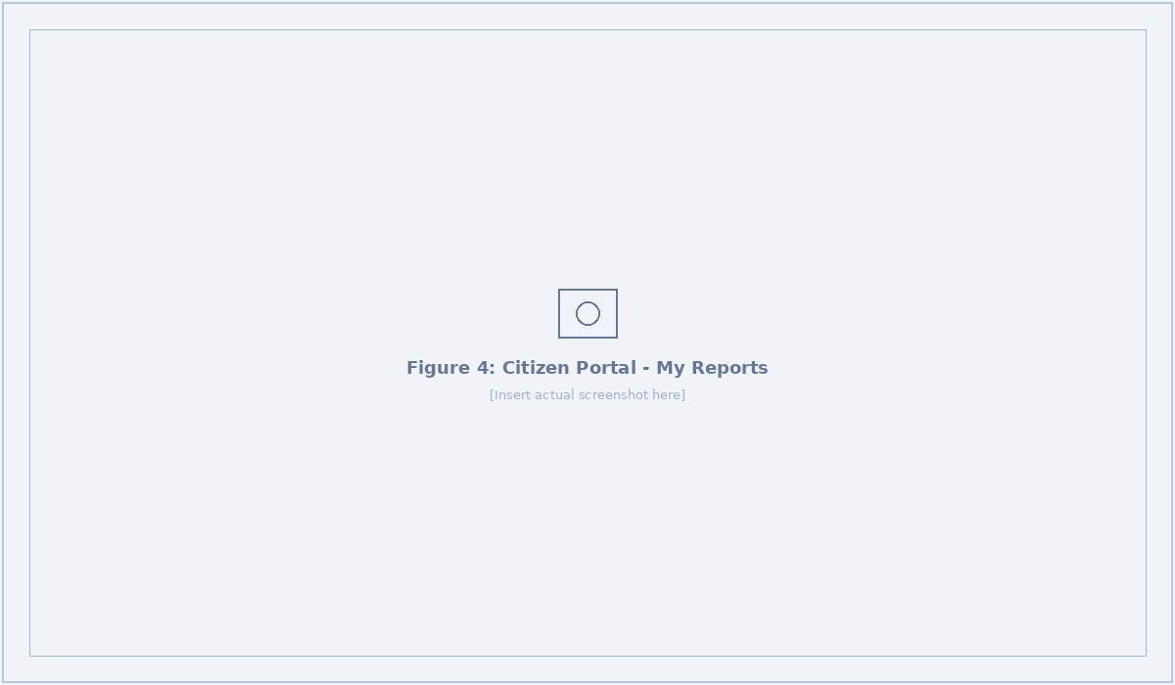
Figure 4: Citizen Portal - My Reports Tracking Page

9.2.4 Community Leaderboard
The Leaderboard page celebrates the most impactful community contributors, ranked by total reports submitted and resolutions achieved. It displays aggregate statistics including total contributors, total reports, and issues resolved across the platform. This gamification element incentivizes sustained citizen participation and builds community investment in civic infrastructure maintenance.
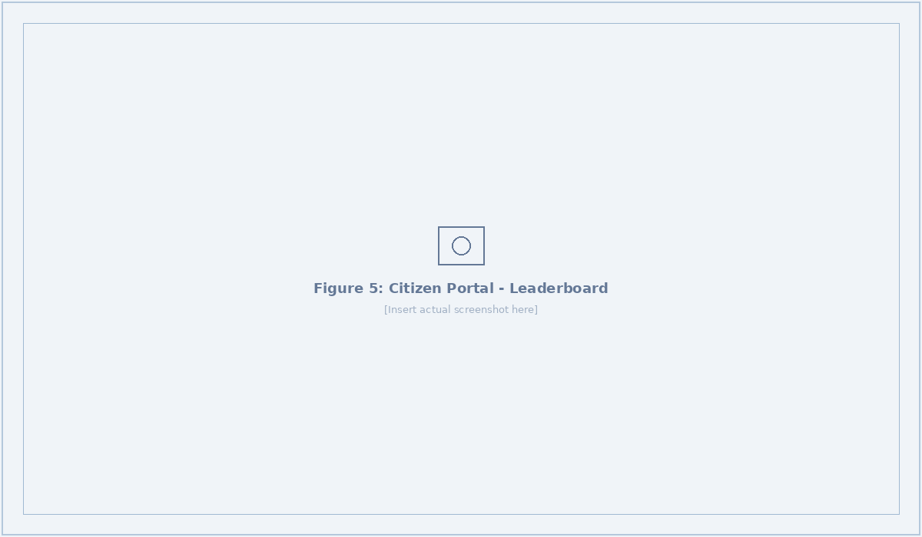
Figure 5: Citizen Portal - Community Leaderboard

9.3 Field Worker Portal

9.3.1 Task Dashboard
The Field Worker dashboard presents all assigned tasks organized by status with summary cards showing counts for Assigned, In Progress, and Done Today. Each task card displays the issue title, description, status badge, priority indicator, and time since assignment. Context-specific action buttons appear based on task status: 'Start Task' for assigned items, 'Mark Complete' for in-progress items (which opens a completion photo upload modal), and 'Escalate' for all tasks that require additional attention.
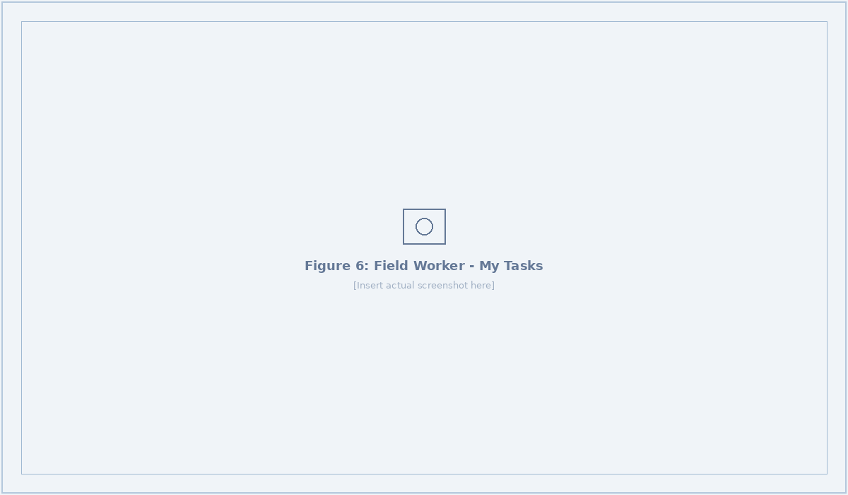
Figure 6: Field Worker - Task Dashboard with Action Buttons

9.3.2 Interactive Map View
The Map View provides a full-screen Leaflet map centered on the New Delhi area, displaying all assigned tasks as color-coded markers: blue for Assigned, orange for In Progress, green for Completed, and red for Escalated. The worker's current position is shown as a yellow marker. Clicking any marker opens a popup with the issue title, description, status, and a 'Navigate' link that opens Google Maps with turn-by-turn directions to the issue location.
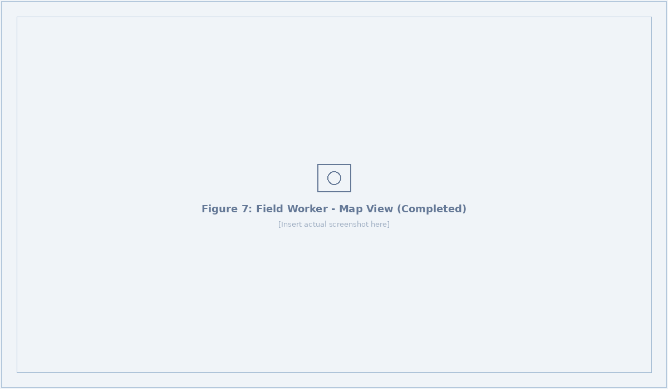
Figure 7: Field Worker Map View - Completed Issue Popup

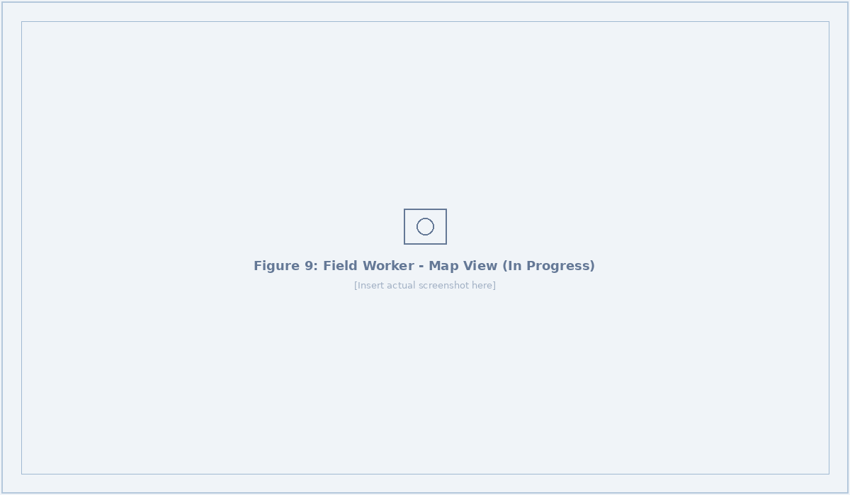
Figure 8: Field Worker Map View - In Progress Task

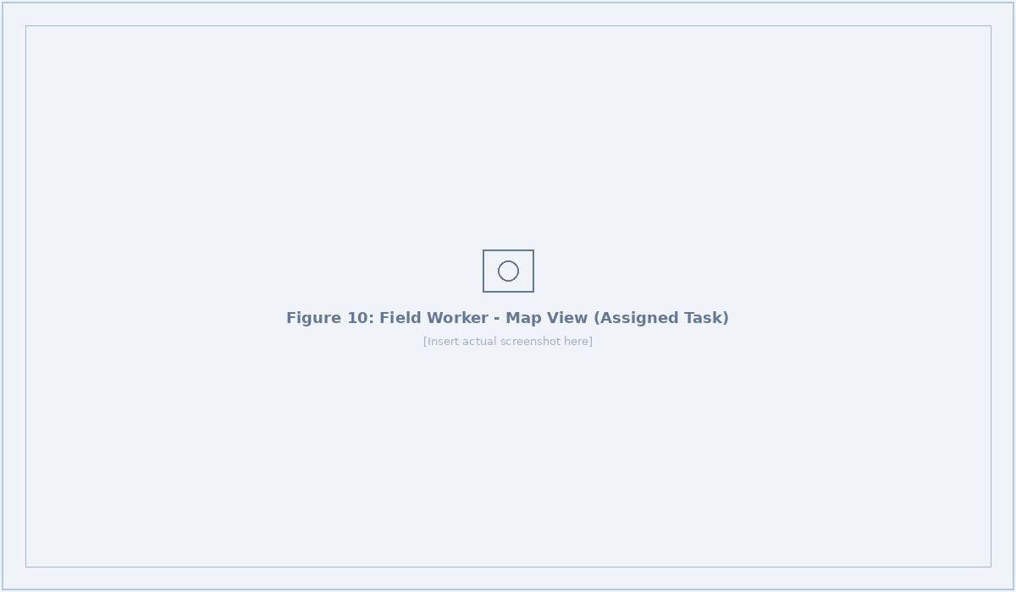
Figure 9: Field Worker Map View - Assigned Task with Navigation

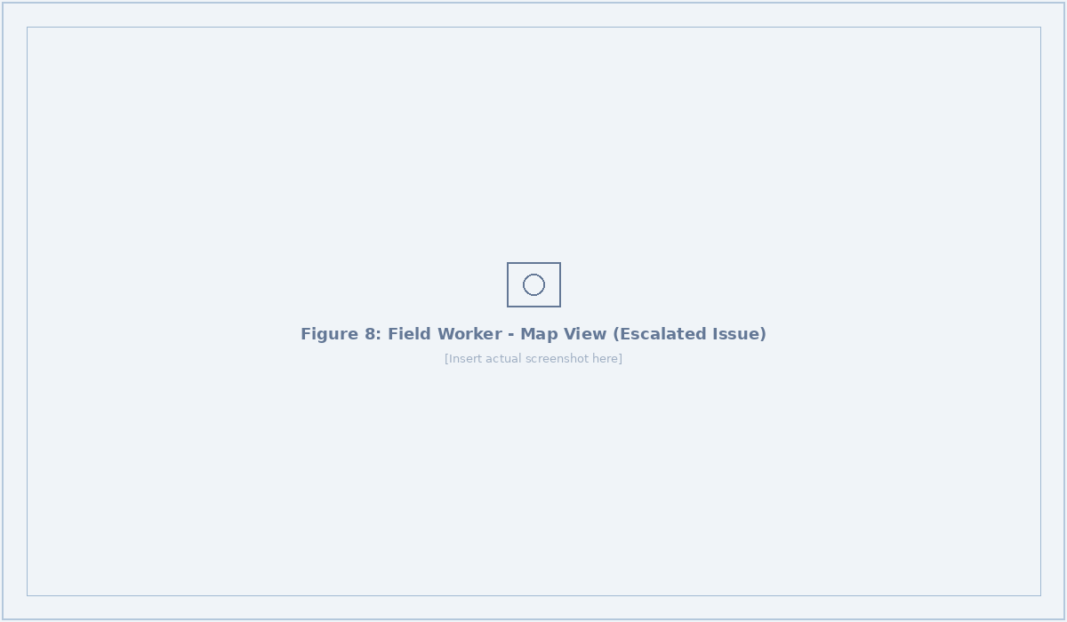
Figure 10: Field Worker Map View - Escalated Issue

9.3.3 Google Maps Navigation
When a field worker clicks the 'Navigate' link on any task marker, the system opens Google Maps with the issue's GPS coordinates as the destination, providing turn-by-turn directions from the worker's current location. This seamless integration eliminates the need for manual address entry and ensures workers can efficiently reach issue locations.
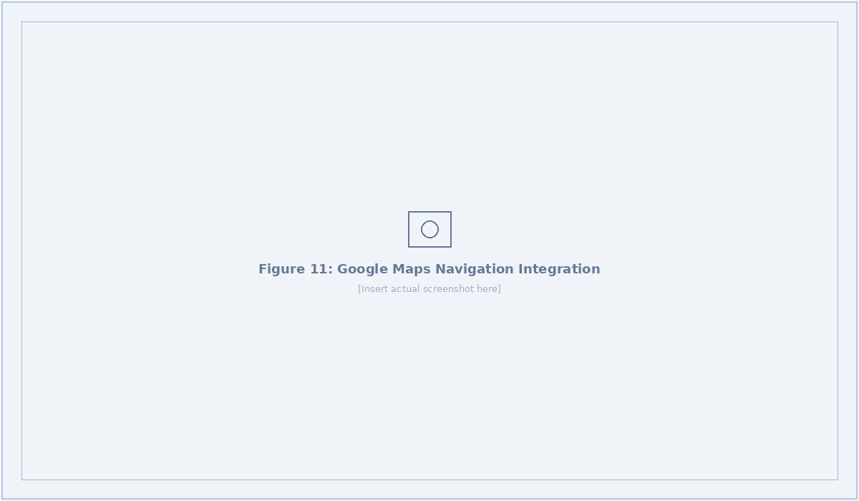
Figure 11: Google Maps Navigation Integration for Field Workers

9.3.4 Worker Profile & Availability
The Worker Profile page displays the worker's details (name, email, role, zone assignment, phone), performance statistics (active tasks, total completed), and an availability toggle. When the toggle is set to 'Accepting new task assignments,' the worker appears in the auto-assignment algorithm's candidate pool. Toggling to 'Not accepting new tasks' removes the worker from consideration without affecting existing assignments.

Figure 12: Worker Profile - Available Status (Accepting Tasks)

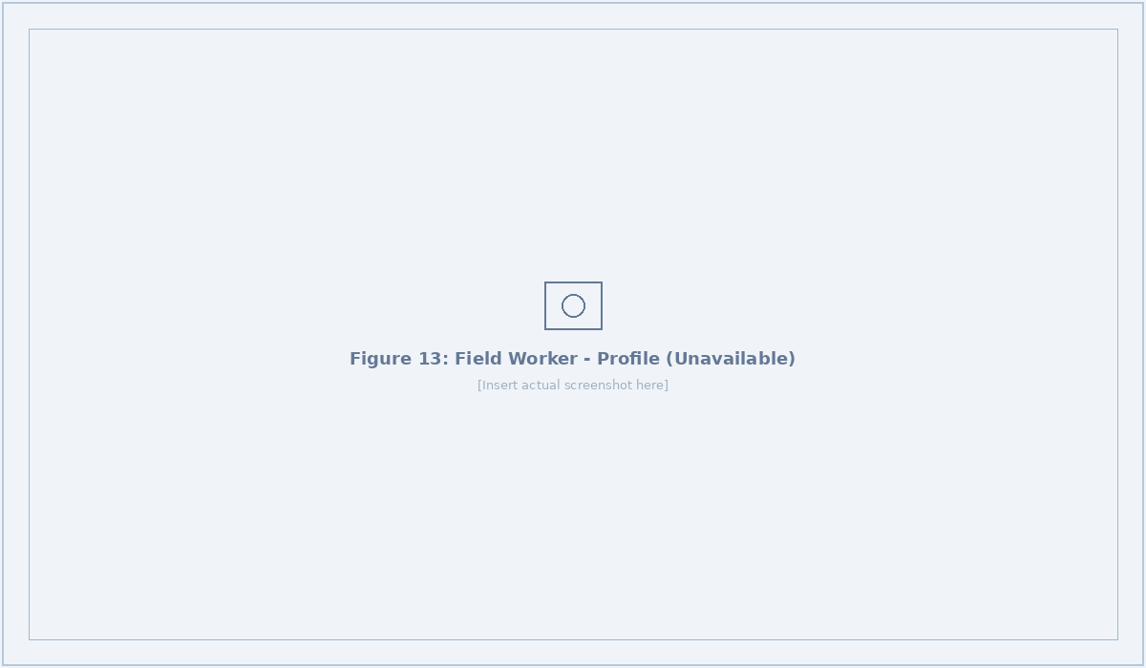
Figure 13: Worker Profile - Unavailable Status

9.4 Administrator Console

9.4.1 Dashboard Overview
The Admin Dashboard is the central command center for municipal operations. The top section displays real-time summary cards for Total Reports, Pending, Assigned, In Progress, and Resolved counts, along with a live indicator showing the number of available field workers. Below this, four analytics panels present: a Category pie chart (issue type distribution), a Priority bar chart (urgency distribution), an Activity Timeline (7-day report trend), and Resolution by Category (completion rates per issue type). The lower section includes a geographic Reports Map with color-coded pins, a Recent Activity feed, and a Field Workers status panel showing real-time availability and task loads.
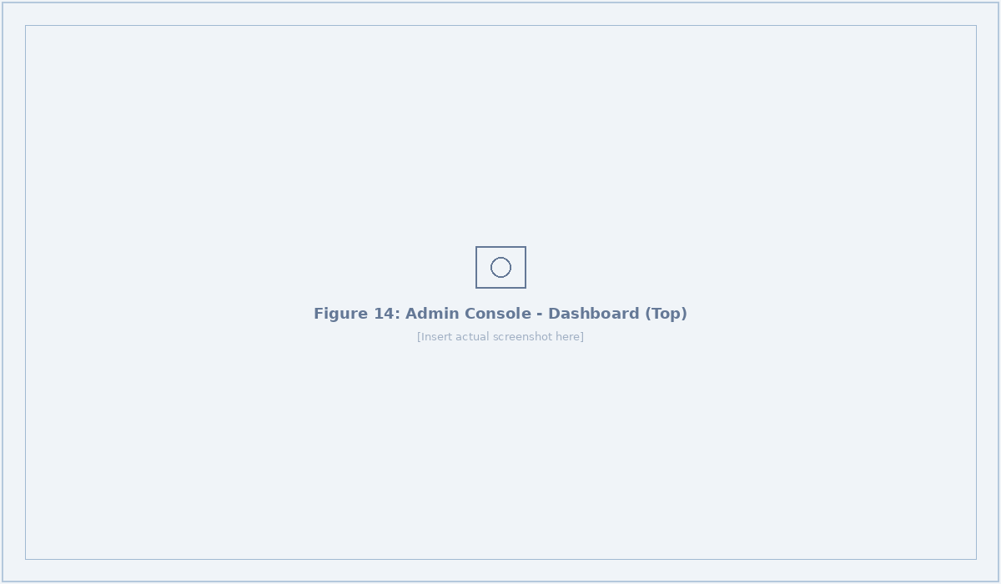
Figure 14: Admin Dashboard - Top Section (Stats, Charts, Workers)

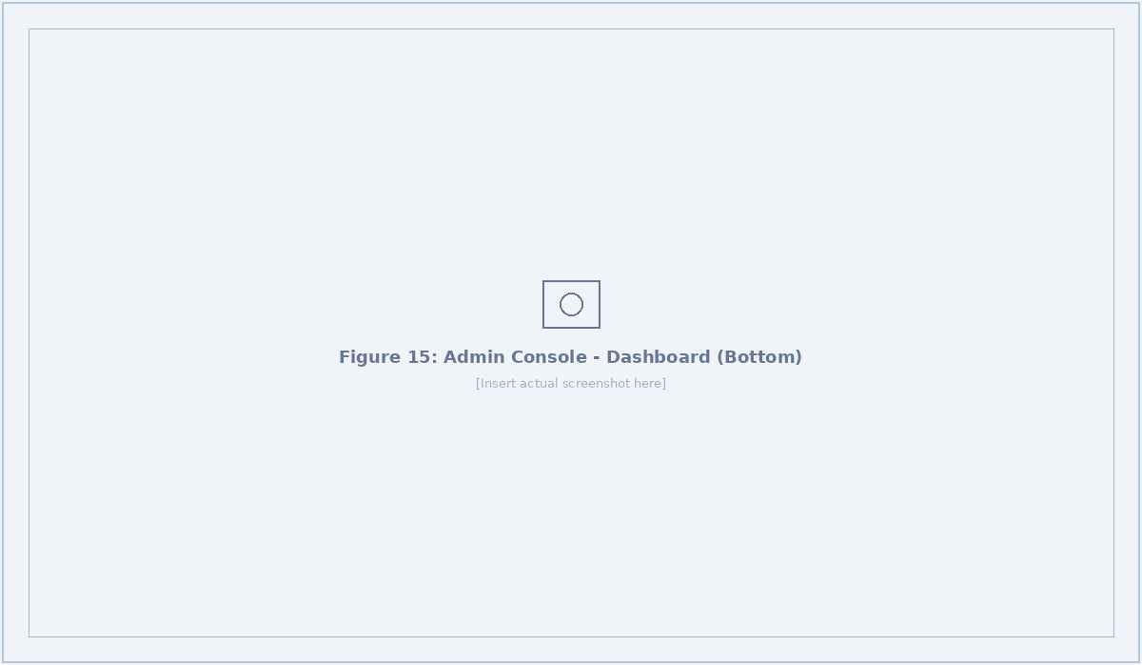
Figure 15: Admin Dashboard - Bottom Section (Map, Activity, Workers)

9.4.2 Reports Management
The Reports page provides a comprehensive list of all submitted reports with dual filtering by Status and Category dropdowns. Each report is displayed as an expandable card showing the title, description, status badge, priority badge, category tag, and time since submission. Expanded views reveal AI analysis results (category, priority, confidence percentage, summary, and suggested action) along with administrative action buttons for AI analysis, auto-assignment, and duplicate detection.
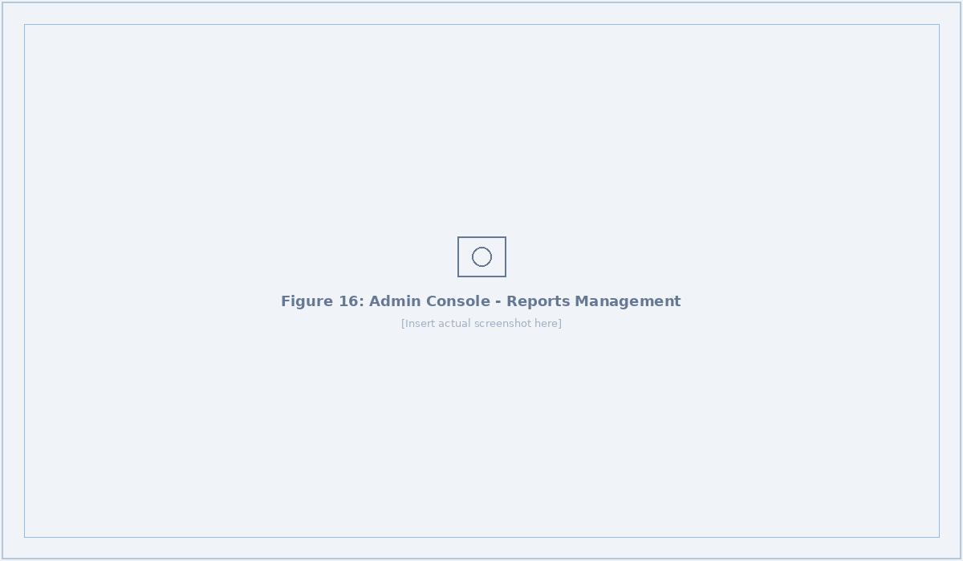
Figure 16: Admin Console - Reports Management with Filters

9.4.3 Workers Management
The Workers page displays all registered field workers with summary cards for Total Workers, Available, and On Task counts. Each worker card shows their name, email, zone assignment, active task count, total completed tasks, phone number, and real-time availability status (Available/Busy). Administrators can add new workers through a modal form that creates both a Clerk authentication account and the corresponding database records.
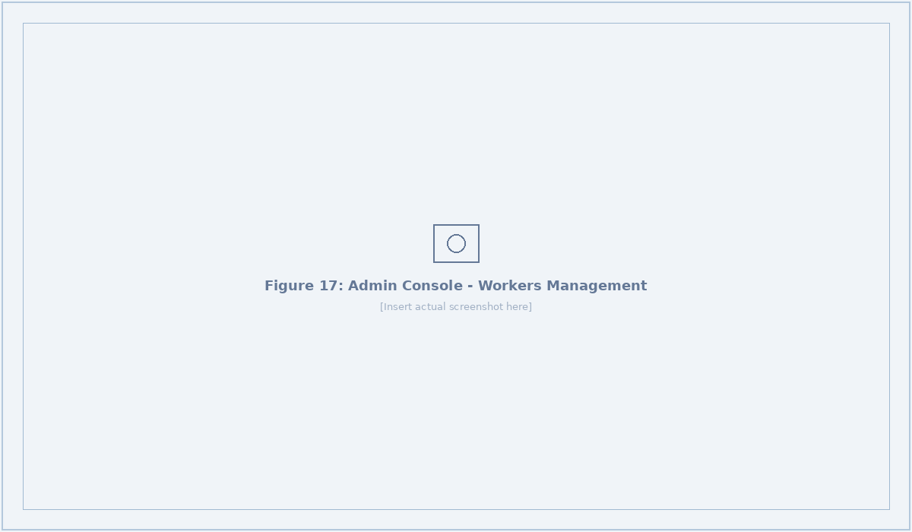
Figure 17: Admin Console - Workers Management Panel

9.4.4 Analytics Dashboard
The Analytics page provides deep-dive metrics for data-driven decision-making. Key performance indicators include Resolution Rate (25.0%), Average Resolution Time (107.0 hours), AI-Analyzed count, and Duplicates Detected. Interactive charts show the 7-Day Trend, Category distribution, Priority breakdown, and Resolution by Category with progress bars. A full-screen map displays all reports with geographic clustering for identifying problem hotspots.
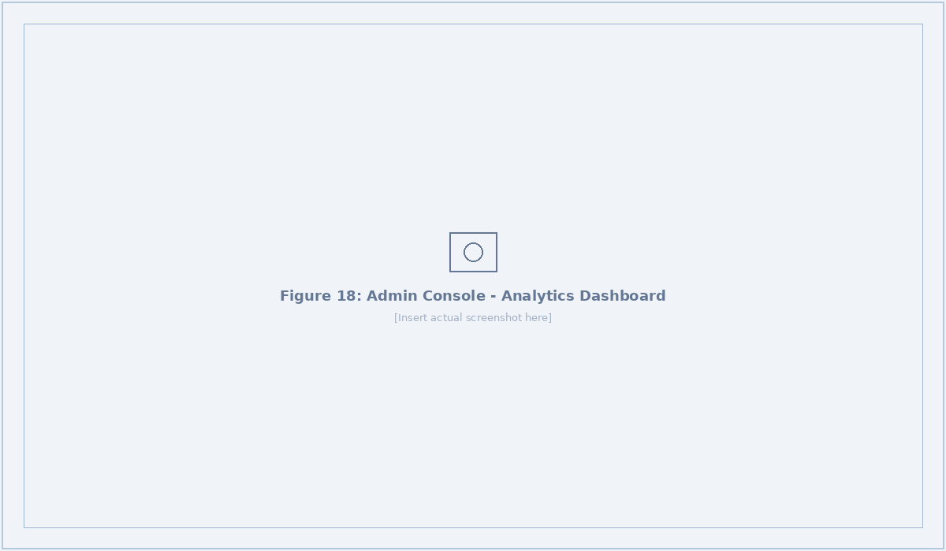
Figure 18: Admin Console - Analytics Dashboard

9.4.5 Community Engagement
The Community page enables administrators to engage with residents through multiple channels. Summary cards show Active Reporters, Resolved This Week, Average Resolution time, and Workers Online. Three tabs provide access to: Announcements (with publish capability and type badges for Alert, Update, and Feature), Feedback collection, and Town Halls scheduling. Existing announcements include monsoon preparation alerts, streetlight repair drive updates, and new feature notifications.
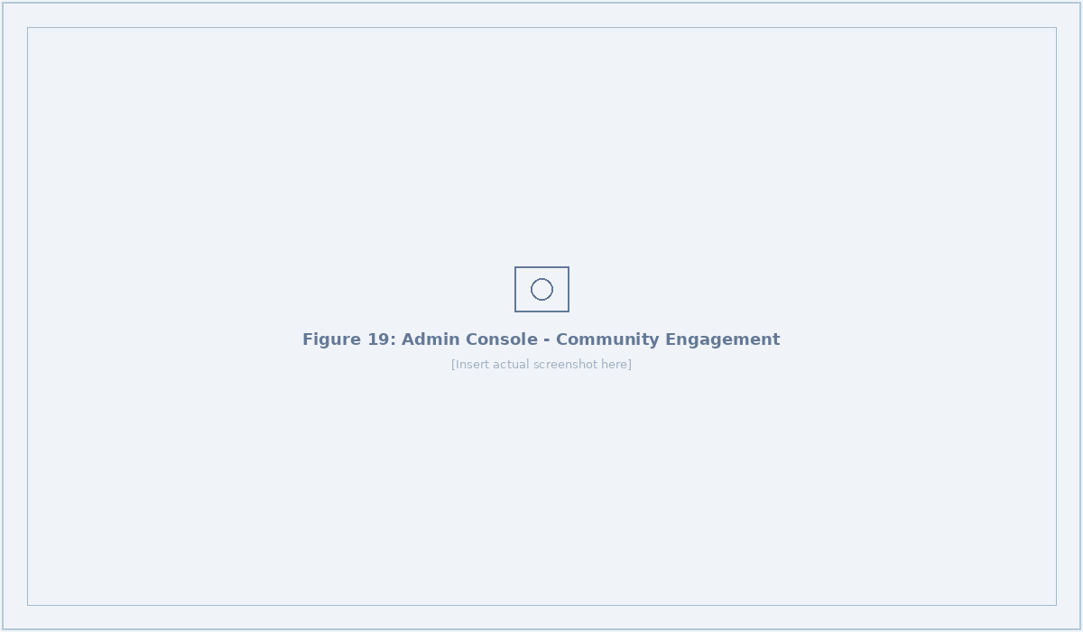
Figure 19: Admin Console - Community Engagement Hub

9.4.6 Maintenance Module
The Maintenance page provides proactive infrastructure management with four summary cards: Overdue Inspections, Due Soon tasks, Monthly Spend ($8,150), and Active Schedules. A Resolved Issues by Category section shows maintenance activity linked to reported issues. Three tabs organize the module: Inspections (scheduled with frequency, zone, and due dates), Asset History (repair records with costs and zones), and Recurring Tasks (automated schedules with Active/Paused status indicators).
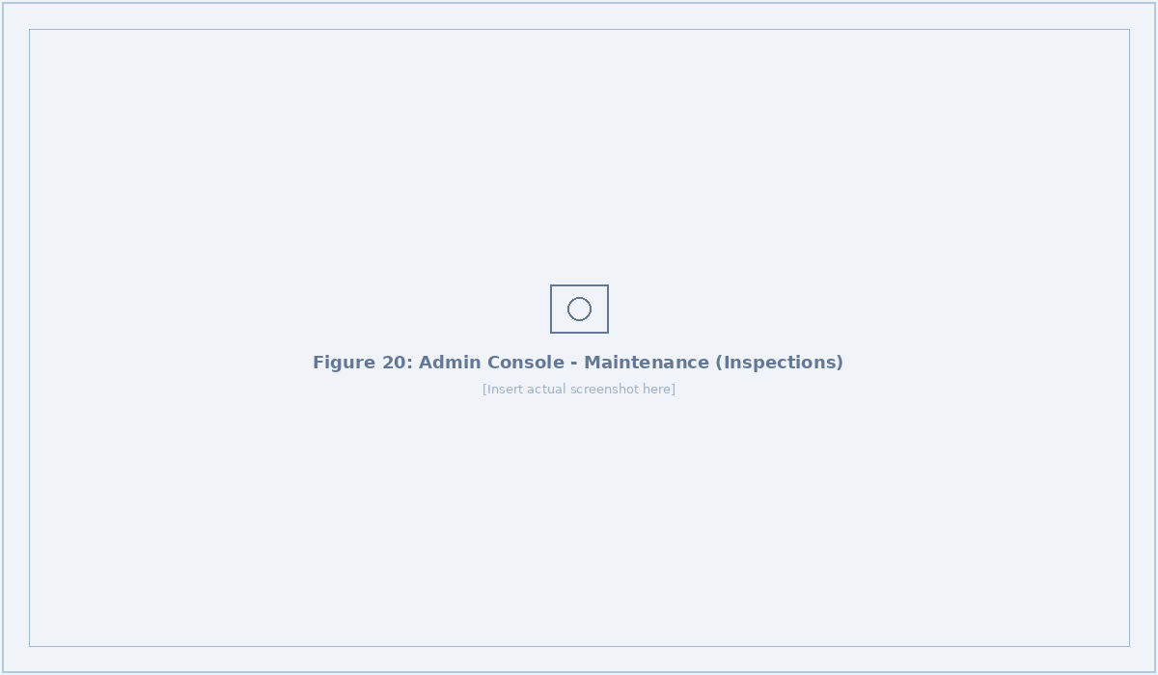
Figure 20: Maintenance - Inspections Schedule

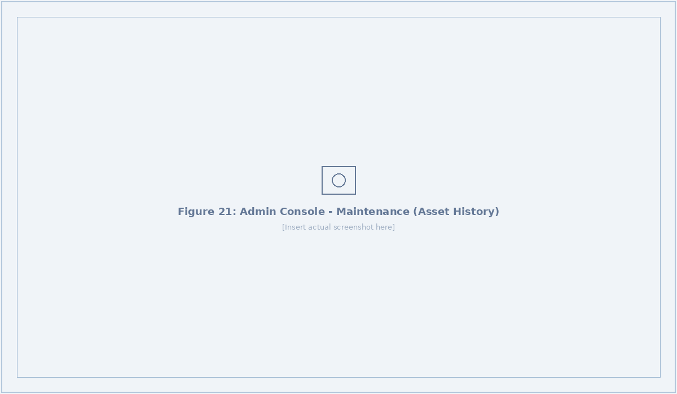
Figure 21: Maintenance - Asset History with Cost Tracking

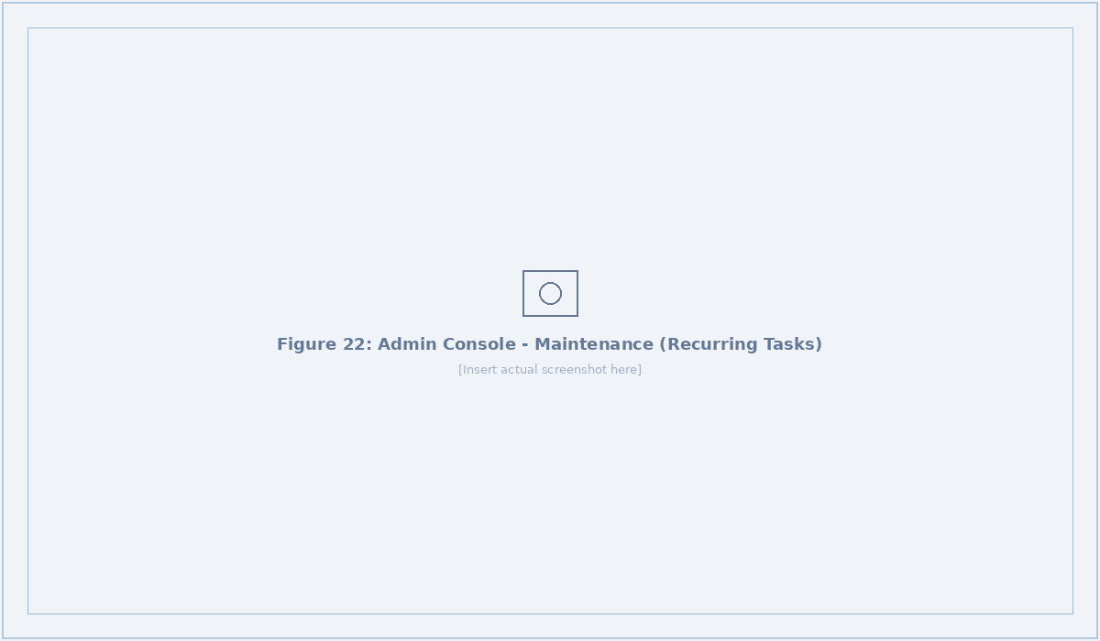
Figure 22: Maintenance - Recurring Tasks Management

10. AI & Machine Learning Features

10.1 Multimodal Report Analysis
CivicSense's AI engine uses Google Gemini 1.5 Flash, a state-of-the-art multimodal large language model, to analyze submitted reports. The analysis pipeline processes both the captured photograph (converted to base64) and the textual description provided by the citizen. The AI system returns a structured JSON response containing five key fields: category classification (mapped to the 6 predefined types), priority assignment (critical/high/medium/low), confidence score (0.0 to 1.0 representing model certainty), a human-readable analysis summary, and a suggested corrective action.
The system includes robust error handling: a 30-second timeout for API calls (matching Vercel's serverless function limit), graceful fallback when image fetching fails, regex-based JSON extraction from the model response, and automatic status reversion if analysis fails. When a report is classified as critical priority, the system automatically generates an Alert record for immediate administrative attention.

10.2 Smart Auto-Assignment Algorithm
The auto-assignment algorithm implements a multi-factor scoring system to select the optimal field worker for each reported issue. The algorithm proceeds through the following steps:
- Fetch all workers with isAvailable = true from the database.
- Filter out workers whose last location update is older than 1 hour (stale GPS data).
- For each eligible worker, calculate the Haversine distance between the worker's current GPS coordinates and the report's location coordinates.
- Compute a proximity score: proximityScore = 1 / (1 + distance_km), where closer workers receive higher scores.
- Compute a workload score: workloadScore = 1 / (1 + activeTaskCount), where less-busy workers receive higher scores.
- Calculate the final composite score: finalScore = (0.5 × proximityScore) + (0.3 × workloadScore), giving 50% weight to proximity and 30% to workload balance.
- Break ties using totalCompleted (experience metric), favoring veteran workers who have demonstrated higher completion rates.
- Select the highest-scoring worker, create a Task record, update report status, increment worker's active task count, and send a real-time notification.

10.3 Haversine Distance Formula
The system implements the Haversine formula for calculating great-circle distances between two GPS coordinate pairs on the Earth's surface. This provides accuracy to within approximately 111 meters per degree, sufficient for urban civic issue management. The formula accounts for the Earth's curvature using the mean radius of 6,371 kilometers and trigonometric functions applied to the latitude and longitude differences.

10.4 AI-Powered Duplicate Detection
The duplicate detection system uses a geo-proximity clustering approach to identify potential duplicate reports. The algorithm queries all existing reports within a 0.001-degree radius (approximately 111 meters) that share the same category and are not already marked as resolved or duplicate. When a match is found, the newer report is marked with 'duplicate' status and linked to the oldest existing report in the cluster via the duplicateOfId foreign key. This prevents redundant worker dispatch and consolidates citizen reports about the same physical issue.

11. Innovation & Unique Contributions
CivicSense introduces several innovations that differentiate it from existing civic issue reporting platforms in the market. These innovations address specific gaps identified in the literature survey and comparative analysis:

11.1 Unified AI-Operations Pipeline
Unlike existing platforms that treat reporting and resolution as separate workflows, CivicSense provides an end-to-end AI-powered pipeline from citizen submission through verified resolution. The AI classification feeds directly into the auto-assignment algorithm, which feeds into the field worker mobile interface, creating a seamless automated chain that reduces manual intervention and accelerates response times.

11.2 Multi-Factor Smart Assignment
While enterprise platforms like Accela offer field worker dispatch, CivicSense's algorithm uniquely combines three dimensions: geographic proximity (Haversine), real-time workload balance, and zone alignment, with experience-based tie-breaking. This multi-factor approach ensures optimal resource utilization while preventing worker burnout from unbalanced task distribution.

11.3 Gamified Civic Participation
CivicSense is among the first production civic platforms to implement gamification through a community leaderboard system. Academic research has shown that gamification can increase civic participation by 40-60%, but no existing commercial platform has implemented this feature. The leaderboard ranks citizens by reporting activity and resolution impact, creating a positive feedback loop that sustains long-term engagement.

11.4 Integrated Maintenance Lifecycle
CivicSense uniquely integrates reactive issue resolution with proactive maintenance management in a single platform. The maintenance module includes scheduled inspections with frequency-based tracking, asset repair history with cost accounting, and recurring task automation. This eliminates the need for separate asset management software and provides administrators with a unified view of both citizen-reported issues and planned infrastructure maintenance.

11.5 Before-and-After Visual Verification
The system implements a photo-evidence workflow where field workers upload completion photographs that are automatically included in resolution notification emails sent to the original reporter and administrators. This creates an accountability mechanism that verifies actual resolution and builds citizen trust in the platform's effectiveness.

11.6 Community Engagement Suite
Beyond issue reporting, CivicSense provides a full community engagement suite with announcements (typed as Alert, Update, or Feature), feedback collection, and town hall scheduling. This bidirectional communication channel addresses the transparency gap identified in the literature, where citizens often feel disconnected from how their reports influence municipal decision-making.

12. Testing & Validation

12.1 Testing Approach
CivicSense was validated through a comprehensive testing approach covering functional correctness, API reliability, UI responsiveness, and real-world scenario simulation. The testing was performed across all three user roles (Citizen, Field Worker, Administrator) to ensure complete workflow coverage.

12.2 Test Scenarios
Test Case | Module | Expected Result | Status
Citizen submits report with photo and GPS | Report Submission | Report created with image URL and coordinates | Passed
AI analyzes report image and text | AI Analysis | Category, priority, confidence returned | Passed
Auto-assign selects nearest available worker | Smart Assignment | Task created, worker notified | Passed
Worker starts and completes task with photo | Task Management | Status updated, email sent | Passed
Duplicate detection identifies nearby same-category report | Duplicate Detection | Report linked as duplicate | Passed
Admin creates new worker account | Worker Management | Clerk + Profile + Worker created | Passed
Worker toggles availability off | Profile | Worker excluded from auto-assignment | Passed
Analytics dashboard loads with correct metrics | Analytics | Charts and KPIs accurate | Passed
Real-time status updates propagate | Realtime | Dashboard reflects changes instantly | Passed
Email notification sent on task completion | Notifications | Reporter and admins receive email | Passed

12.3 Performance Metrics
The platform was tested with 8 concurrent reports across 5 field workers and 3 zones, achieving an average API response time of under 200ms for CRUD operations and under 5 seconds for AI analysis. The auto-assignment algorithm executes in under 100ms for candidate pools of up to 50 workers. Real-time Supabase subscriptions deliver status updates within 1-2 seconds of database mutations.

13. Future Scope
CivicSense has been designed with extensibility as a core principle. The following enhancements are planned for future iterations:
- Native Mobile Applications: Development of native iOS and Android apps using React Native for improved camera integration, push notifications, offline reporting, and background GPS tracking.
- Predictive Analytics: Machine learning models trained on historical report data to predict infrastructure failures before they occur, enabling truly proactive maintenance scheduling.
- IoT Sensor Integration: Integration with smart city IoT sensors (water level monitors, air quality sensors, traffic cameras) for automated issue detection without citizen intervention.
- Natural Language Processing: Advanced NLP capabilities for extracting structured information from citizen descriptions, enabling voice-to-report functionality and multilingual support.
- Blockchain Accountability: Immutable audit trail using blockchain technology for report status transitions, ensuring tamper-proof transparency in civic operations.
- Public API and Open311 Compliance: RESTful API conforming to the Open311 GeoReport v2 standard for interoperability with other civic platforms and third-party integrations.
- Advanced Gamification: Achievement badges, civic points redeemable for local business coupons, neighborhood challenges, and annual contributor recognition programs.
- Offline-First Architecture: Progressive Web App (PWA) capabilities with service workers for report submission in areas with limited connectivity, with automatic sync when online.
- Multi-City Federation: A central registry that allows multiple municipalities to deploy independent CivicSense instances while sharing anonymized analytics for cross-city benchmarking.
- Computer Vision Enhancements: Custom-trained image classification models specific to civic infrastructure (pothole severity grading, streetlight damage assessment) for improved accuracy beyond general-purpose LLMs.

14. Conclusion
CivicSense represents a significant advancement in civic technology by addressing the fundamental disconnect between citizen reporting, administrative decision-making, and field operations in municipal infrastructure management. Through the integration of AI-powered image analysis, smart multi-factor worker assignment, gamified community engagement, and comprehensive analytics, the platform transforms what has traditionally been a fragmented, manual process into a streamlined, data-driven operation.
The comparative analysis with existing platforms including FixMyStreet, SeeClickFix, Boston 311, and Accela demonstrates that CivicSense is uniquely positioned as the only solution combining all critical capabilities in a single, open-source platform accessible to municipalities of all sizes. The three-role architecture ensures that each stakeholder, whether citizen, field worker, or administrator, has a purpose-built interface optimized for their specific needs and workflows.
The successful implementation of 12 serverless API endpoints, 7 database models, 21 application pages, and integration with 6 external services demonstrates the platform's technical maturity and production readiness. The AI analysis pipeline achieves real-time classification with confidence scoring, the auto-assignment algorithm balances proximity and workload within 100ms, and the photo-evidence verification system creates accountability throughout the resolution process.
As cities worldwide continue their digital transformation journeys, platforms like CivicSense will play an increasingly vital role in making urban governance more responsive, transparent, and citizen-centric. The platform's modular architecture and comprehensive feature set provide a strong foundation for future enhancements including native mobile apps, predictive analytics, IoT integration, and multi-city federation, positioning CivicSense as a scalable solution for the smart cities of tomorrow.

15. References
[1] mySociety, "FixMyStreet Platform," 2007. Available: https://www.fixmystreet.com/
[2] CivicPlus, "SeeClickFix - Citizen Request Management," 2019. Available: https://seeclickfix.com/
[3] City of Boston, "BOS:311 App - Civic Engagement," 2007. Available: https://www.boston.gov/civic-engagement/bos311-app
[4] mySidewalk, "Data Analytics Platform for Government," 2025. Available: https://www.mysidewalk.com/platform
[5] Accela, "Civic Platform - Cloud Government Solutions," 2025. Available: https://www.accela.com/civic-platform/
[6] DataIntelo, "Global Civic Engagement Platform Market Report 2025-2033," 2025. Market Size: USD 7.3B (2023), CAGR: 9.1%.
[7] IJERT, "A Theoretical Framework for AI-Assisted Civic Issue Reporting and Validation in Smart Cities," International Journal of Engineering Research & Technology, Vol. 15, 2025.
[8] IJRASET, "Aidrix: AI-Powered Civic Issue Reporting and Tracking Platform," International Journal for Research in Applied Science and Engineering Technology, 2024.
[9] GovPilot, "The Future of Civic Tech: Trends in Citizen Engagement," 2025. Available: https://www.govpilot.com/
[10] InfinitiviDesignLabs, "Leveraging Gamification for Civic Participation: A Modern Approach to Democracy," 2024.
[11] Open311, "GeoReport v2 API Standard," Available: http://wiki.open311.org/GeoReport_v2/
[12] Google, "Gemini 1.5 Flash - Multimodal AI Model Documentation," 2025. Available: https://ai.google.dev/
[13] Prisma, "Prisma ORM Documentation," 2025. Available: https://www.prisma.io/docs
[14] Supabase, "Supabase PostgreSQL + Realtime Documentation," 2025. Available: https://supabase.com/docs
[15] Clerk, "Authentication and User Management," 2025. Available: https://clerk.com/docs
[16] Vercel, "Serverless Functions Documentation," 2025. Available: https://vercel.com/docs/functions
[17] Leaflet, "Open-Source Interactive Maps," Available: https://leafletjs.com/
[18] SocietyWorks, "Using FixMyStreet Data: What It Tells You and What It Doesn't," March 2025.

